Evaluation

# List of Completed Tasks and Completion Times

1. Make the player move (5 minutes)
2. Make the player jump (5 minutes)
3. Camera movement (40 minutes)
   1. Clamp camera movement up/down, but not left and right. (30 minutes)
   2. The player model will always face the direction that the camera is looking in (10 minutes)
4. Create or get two portal prefabs (20 minutes)
   1. Colored differently
   2. Has a camera facing outwards
   3. Tag one “BluePortal” and the other “OrangePortal”
5. Make a PortalController script (1 minute)
   1. Tag it “PortalController”
6. Portal Controller keeps a reference to both portals at all times (5 minutes)
   1. Will have a public method that will set the reference for the portals
7. Portal Controller will destroy a portal if another one of that type exists (5 minutes)
8. When the player walks into a portal, it will move them to the other portal (20 minutes)
   1. Ensure that you don’t accidentally go through the second portal immediately after going through the first one.
9. Create a portal gun model (5 minutes)
10. Create a portal gun projectile model(10 minutes)
11. Make the portal gun shoot the portal gun projectile (20 minutes)
    1. Always moves forward
    2. Left click for blue projectile.
    3. Right click for orange projectile.
12. Make the portal gun projectile instantiate a portal prefab on a surface on contact (55 minutes)
    1. Keep a reference to both objects once instantiated (5 minutes)
    2. Use RaycastHit.normal to determine the direction the portal prefab will face (20 minutes)
    3. Ensure portal has enough space to be placed (use the portal surface object extents and do a calculation) (30 minutes)
       1. Do a small overlap cube to check what object we are on
       2. If there is not enough space then disallow placement
13. Ensure the cameras that are on the portals will render their view to the other portal’s surface. (40 minutes)

# A description of what worked, did not work, or is still unknown

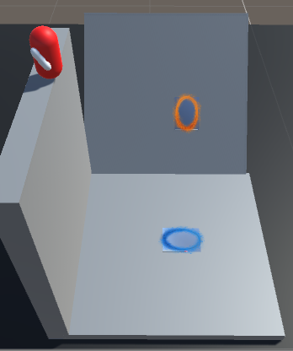Everything I attempted to do in this prototype worked.

Two unknown things I need to work on in the future is:

1. How to use a mask to hide the corners of the portals
2. How to conserve and re-direct the velocity of the player when they fall into a portal…

For an example of number 2. In the image to the right we can see the scenario I’m talking about.

In this scenario, if the player jumped into the blue portal, their downward velocity will increase… and as they exit the orange portal, their velocity will **still be pointing down**.   
So instead of shooting out of the orange portal and redirecting the velocity, it will instead cause him to continue moving downards…

This is something I don’t want. I want the players velocity to be redirected depending on the angle of the portal. I don’t know how to do this yet but I will look into it as I continue this project.

# An evaluation of the data to determine if any changes need to be made to the Final project.

Currently there are a lot of things about the prototype I want to change, mostly asthetics like the corners of the portal’s render texture, the bland textures, and the bland models.

However, since everything in my prototype worked then I think there are no changes that need to be made to the final project ***yet***. Once I add more to it, it will most likely become more complicated and I might need to change the way some of my mechanics work.